Scope and Priorities
- Connect MSFT Agents to DB tools (Genie One MCP, Genie Agents, UC functions, etc.)
Connect Databricks agents with WorkIQ, Microsoft Graph, and other Microsoft MCP services in both directions.

- I think the open items listed on this would be good items to prep for and work through – architecture diagram
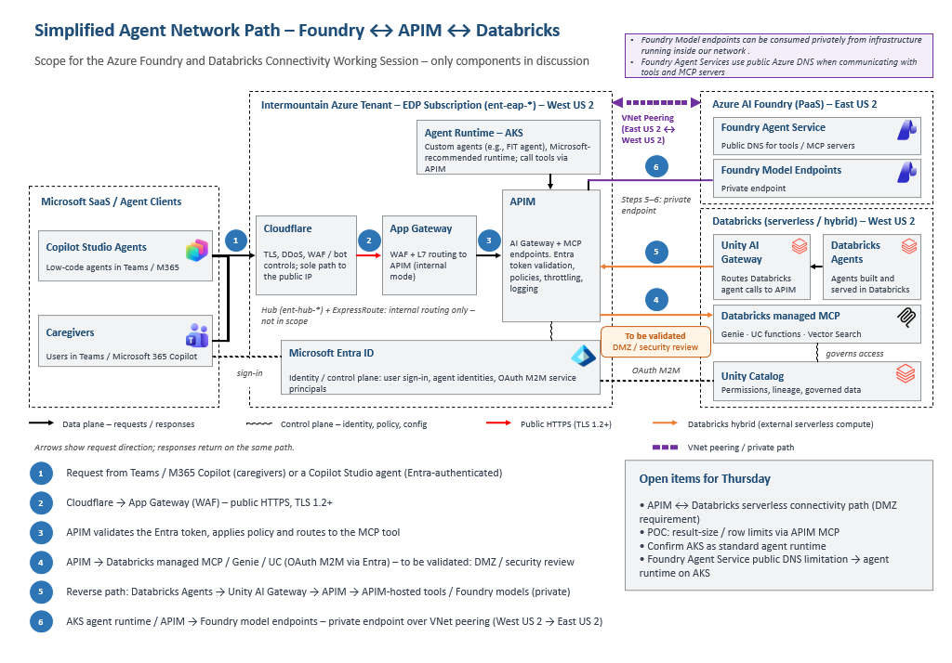
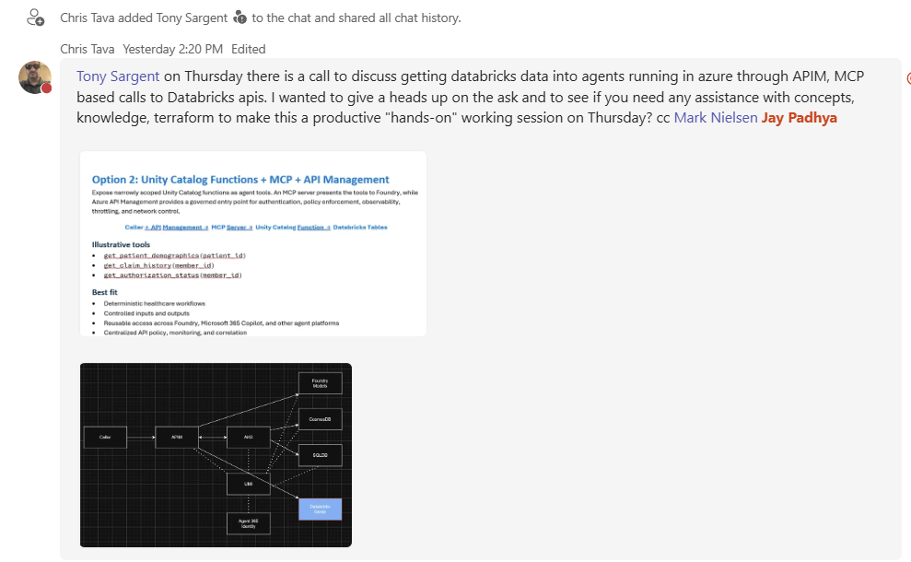
Chris mentioned -- Tony Sargent on Thursday there is a call to discuss getting databricks data into agents running in azure through APIM, MCP based calls to Databricks apis. I wanted to give a heads up on the ask and to see if you need any assistance with concepts, knowledge, terraform to make this a productive "hands-on" working session on Thursday?
Mark -- It's not specific to any one project, but Ventures is probably the one to highlight the DB MCP tool need from MSFT agents. We have a handful of others that can also benefit from MSFT MCP tools being made available to DB agents
